- Search for files and directories by size

- ls -lrt [ To view the existing files and directories with their sizes before searching ]
- find . -type f -size +4k [ To list regular files larger than 4 KB ]
- find . -type d -size 4k [ To list directories that are exactly 4 KB in size ]
- find . -type f -size +1k -size -4k [ To list regular files that are larger than 1 KB and smaller than 4 KB ]

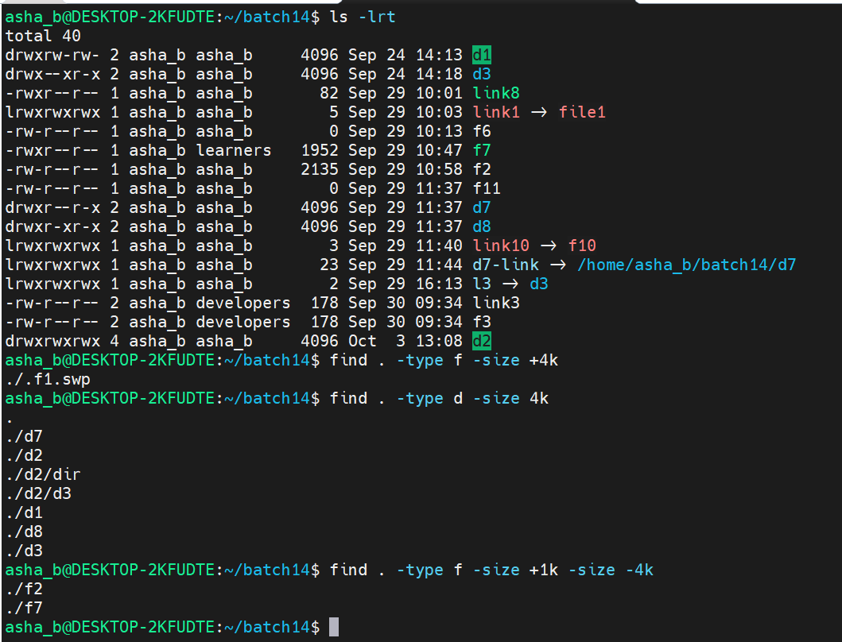

- tree [ To display files, directories and links in a hierarchical tree structure ]
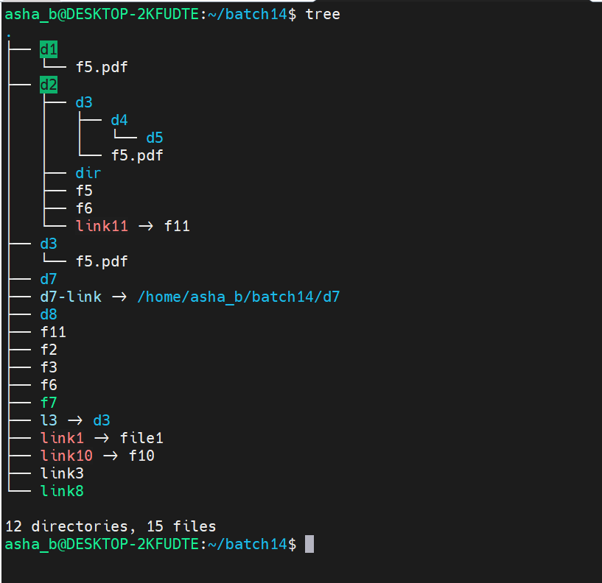

- Limit the search depth using -maxdepth

- find . -maxdepth 2 -type f [ To list regular files up to 2 levels deep ]
- find . -maxdepth 2 -type d [ To list directories up to 2 levels deep ]
- find . -maxdepth 2 -type l [ To list symbolic links up to 2 levels deep ]
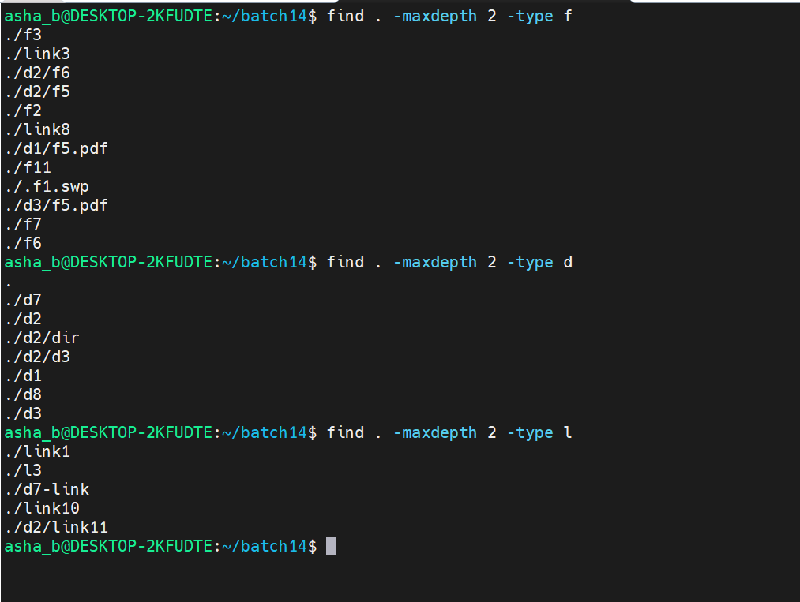

- Limit the search depth using -mindepth

- find . -mindepth 2 -type f [ To list regular files starting from 2 levels deep ]
- find . -mindepth 2 -type d [ To list directories starting from 2 levels deep ]
- find . -mindepth 2 -type l [ To list symbolic links starting from 2 levels deep ]
- find . -mindepth 3 -type d [ To list directories starting from 3 levels deep ]
- find . -mindepth 2 -maxdepth 3 -type d [ To list directories that are between 2 and 3 levels deep ]
- find . -mindepth 2 -maxdepth 3 -type f [ To list regular files that are between 2 and 3 levels deep ]
- find . -mindepth 2 -maxdepth 3 -type l [ To list symbolic links that are between 2 and 3 levels deep ]
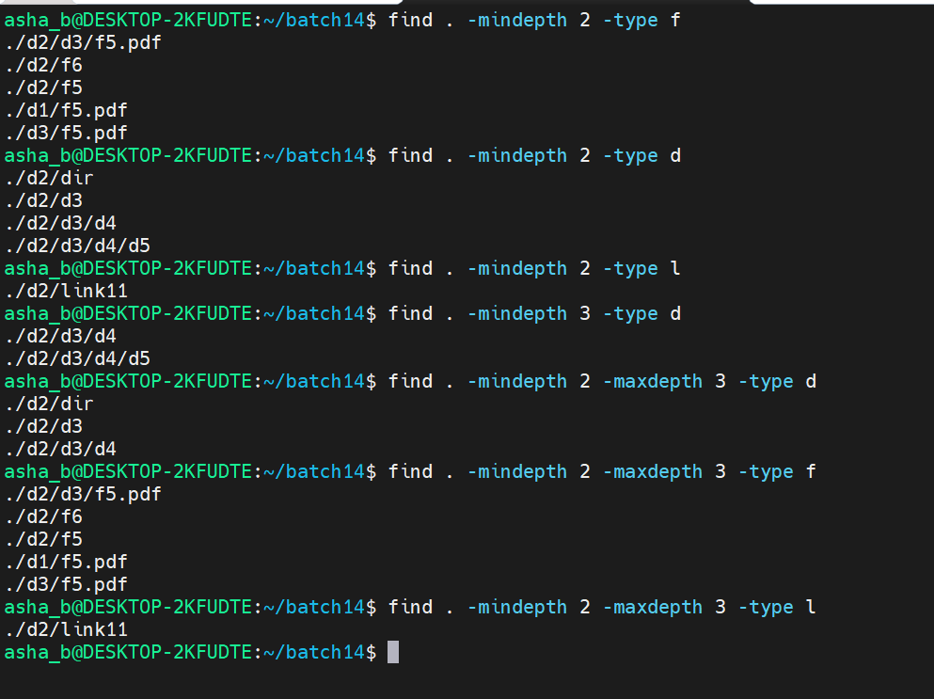

- find . -mindepth 1 -maxdepth 2 -type f [ To list regular files between 1 and 2 levels deep ]
- find . -mindepth 1 -maxdepth 2 -type d [ To list directories between 1 and 2 levels deep ]
- find . -mindepth 1 -maxdepth 2 -type l [ To list symbolic links between 1 and 2 levels deep ]
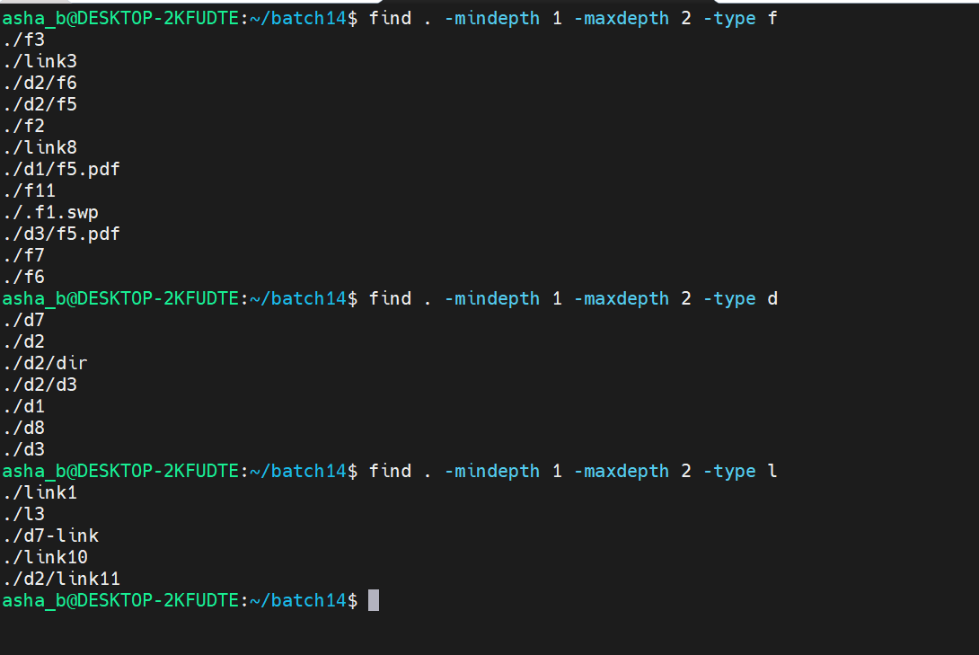

- touch f7.txt [ To create a new, empty file named f7.txt ]
- tree [ To verify f7.txt now appears in the directory structure ]
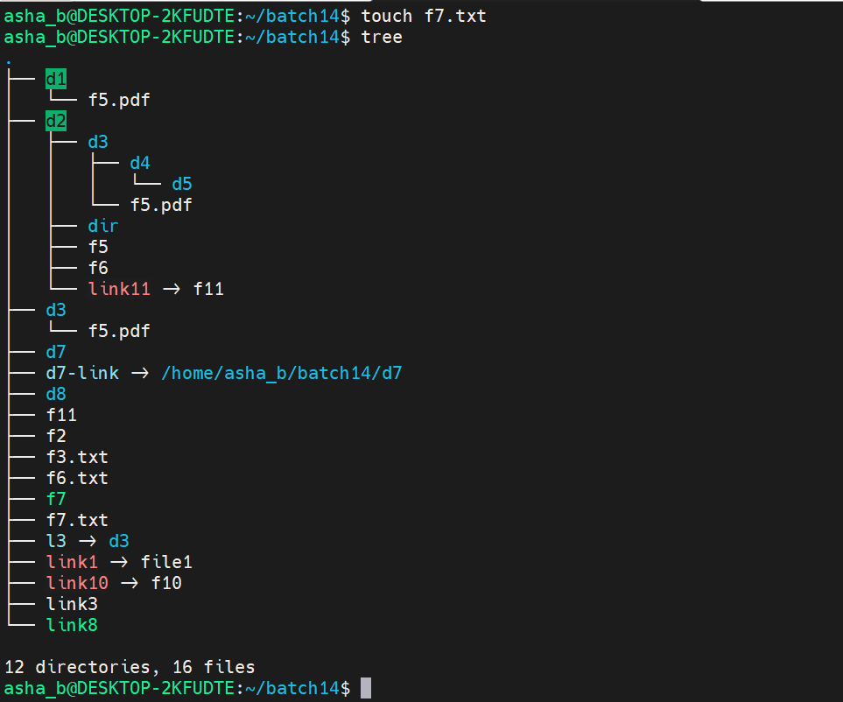

- find . -name "*.txt" [ To list all files with a .txt extension ]
- find . -type f -mtime -10 [ To list regular files that were modified within the last 10 days ]
- find . -type d -mtime +5 [ To list directories that were last modified more than 5 days ago ]
- find . -type f ! -empty [ To list regular files that are NOT empty ]
- find . -type d ! -empty [ To list directories that are NOT empty ]
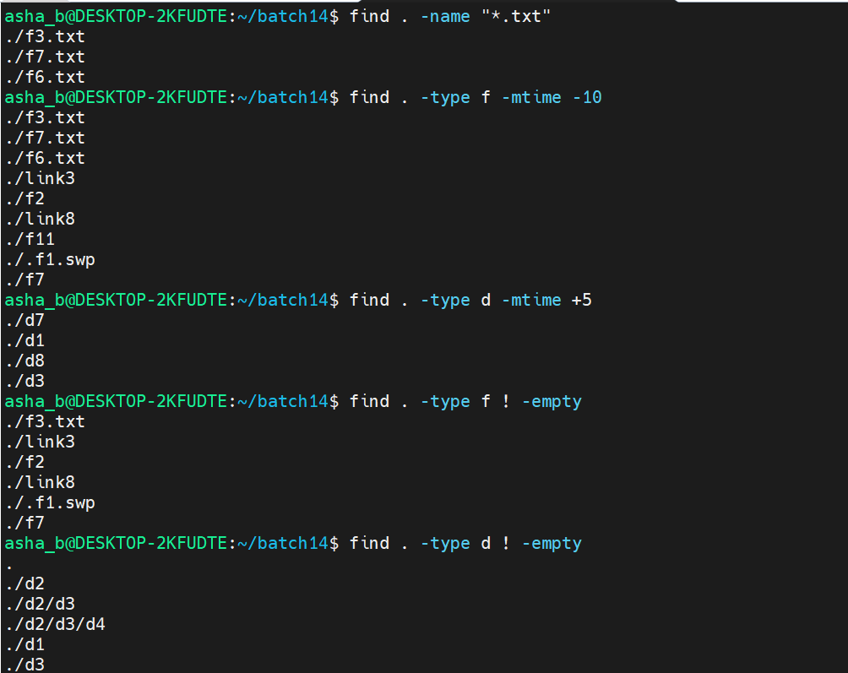

- View network interface and IP address details

- hostname -I [ To display all IP addresses currently assigned to the host's active network interfaces ]
- ifconfig [ To display detailed configuration of all network interfaces, including IP address, netmask, broadcast address and packet statistics ]
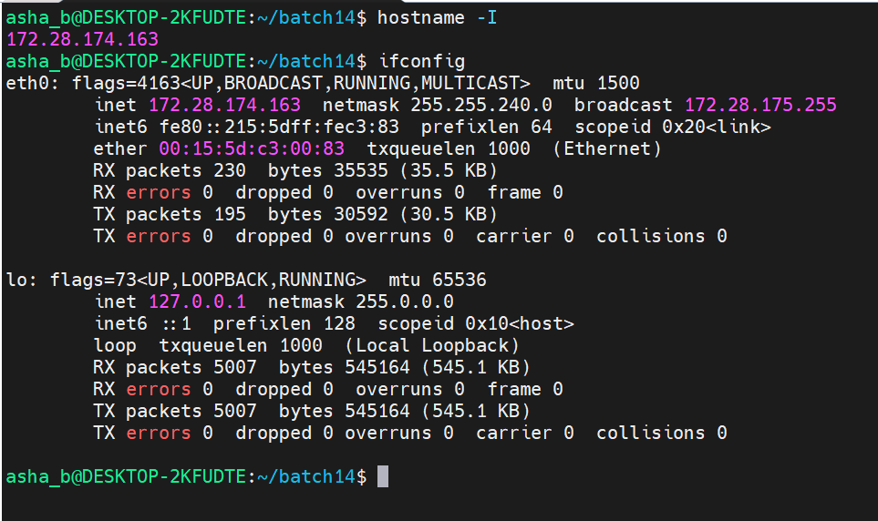

- Test network connectivity to a remote host

- ping google.com [ To check connectivity to google.com by sending ICMP echo requests and measuring the response time; stopped manually using Ctrl+Z ]
- telnet google.com 80 [ To open a raw TCP connection to google.com on port 80 (HTTP), confirming the host is reachable on that port ]

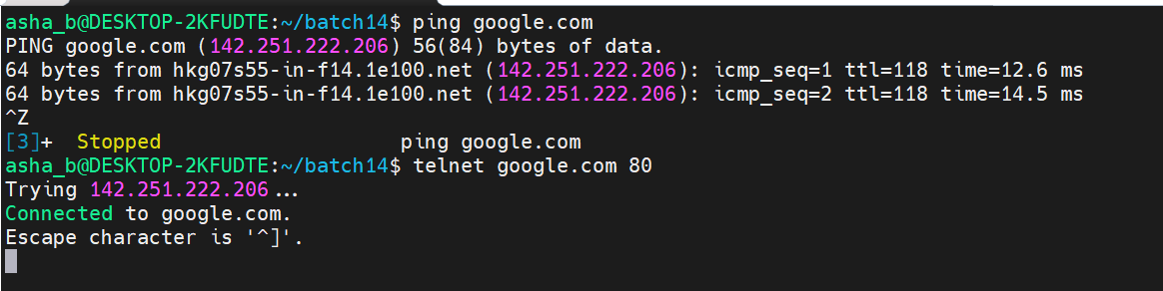

- netstat -a [ To display all active network connections and listening ports, covering TCP/UDP sockets as well as UNIX domain sockets ]

